Integer Data Type
Rosenivitha J
192424009
ITA0406 - STATISTICS WITH R PROGRAMMING
Activity program 1
1. Write an R program to create an integer variable with value 100 and display its data
type.
Program
x <- 100L
x
class(x)
Output
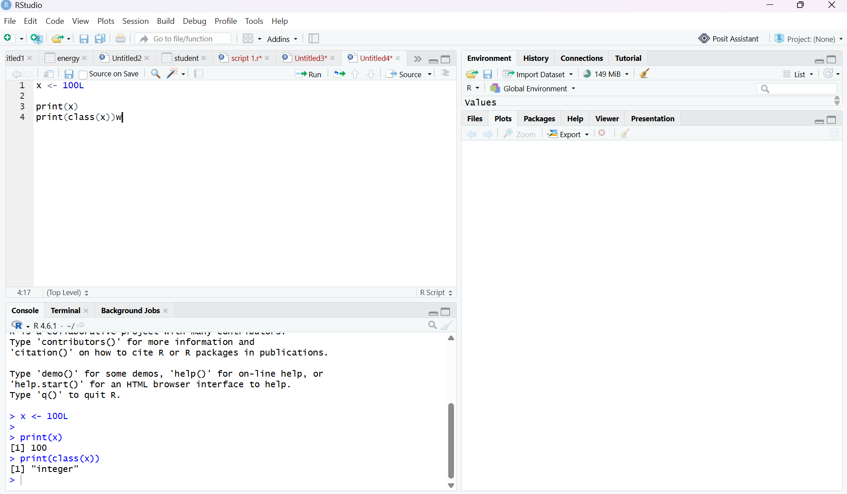
2. Write an R program to create two integer variables (25L and 15L) and find their sum,
difference, and product.
Program
a <- 25L
b <- 15L
a + b
a - b
a * b
Output
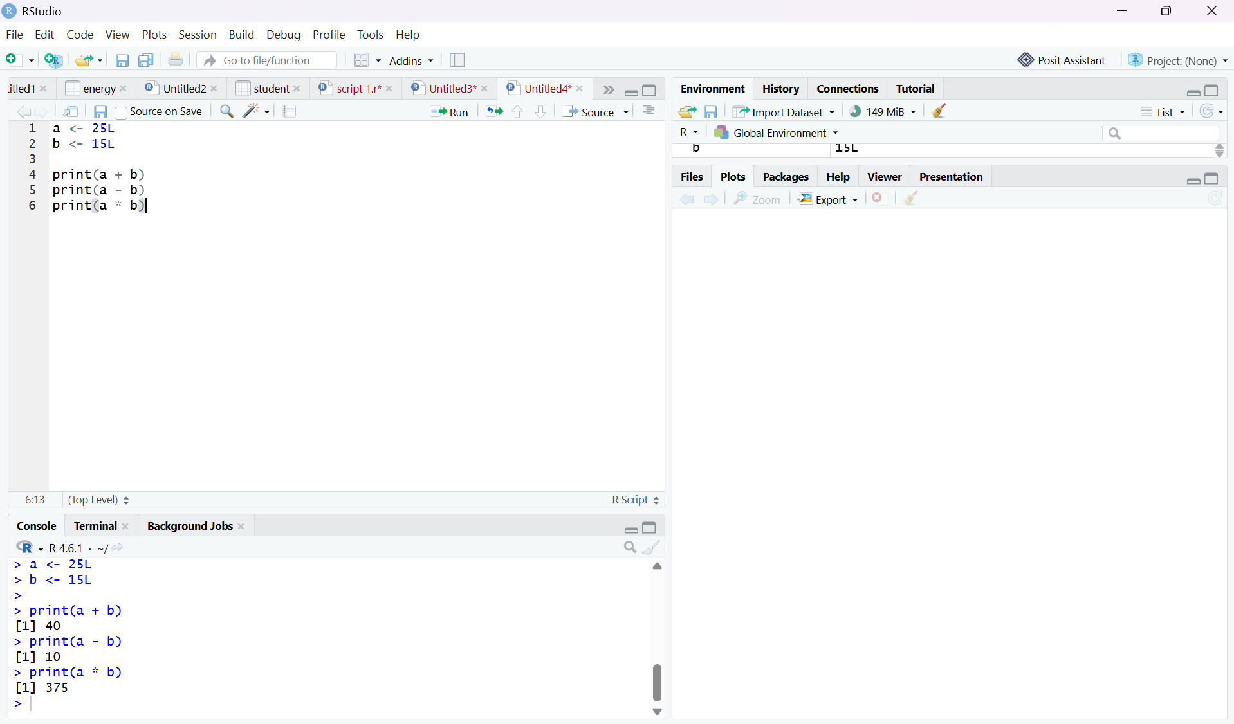

3. Write an R program to store the marks of 5 students as integers in a vector and
calculate the average mark.
Program
marks <- c(80L, 75L, 90L, 85L, 70L)
average <- mean(marks)
marks
average
Output
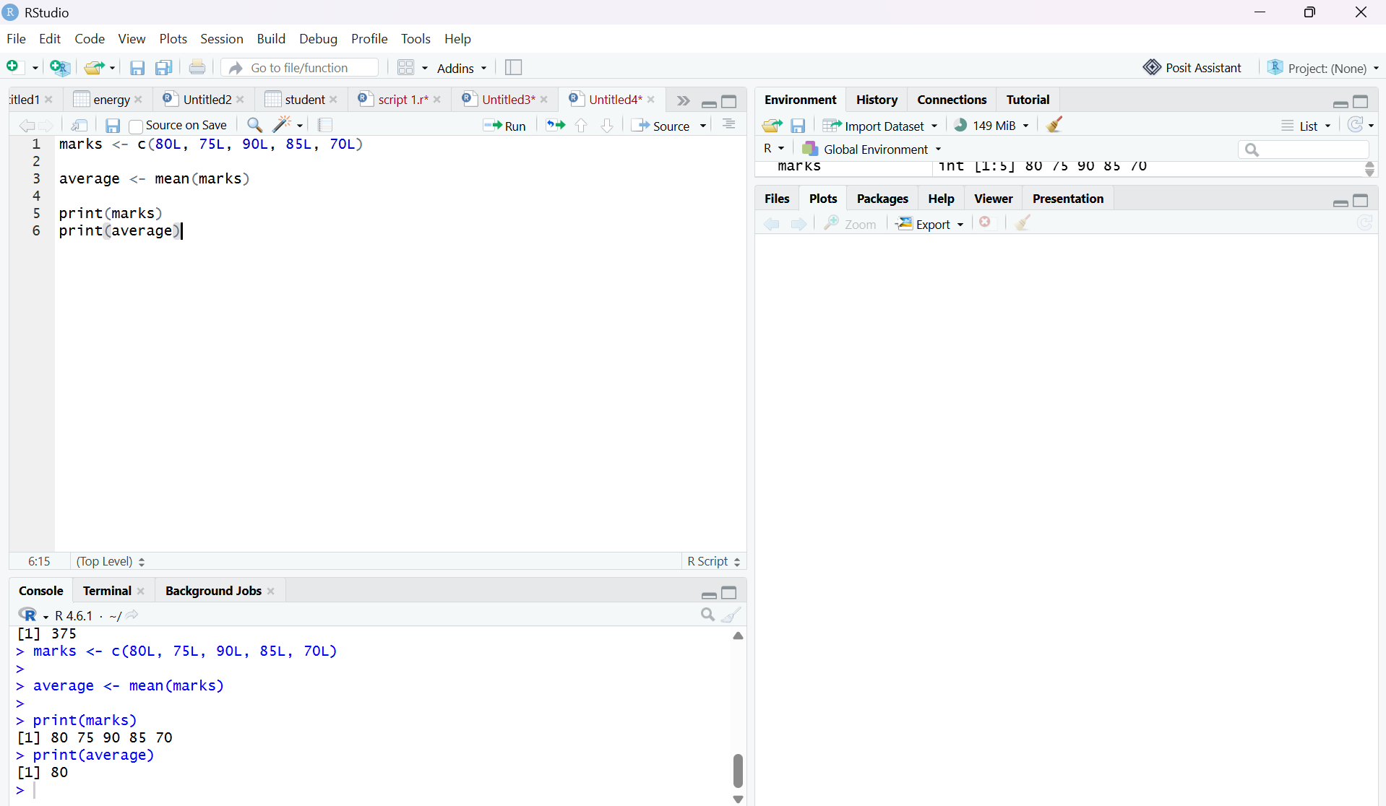

Numeric Data Type
4. Write an R program to create a numeric variable with value 45.75 and check its class.
Program
x <- 45.75
x
class(x)
Output
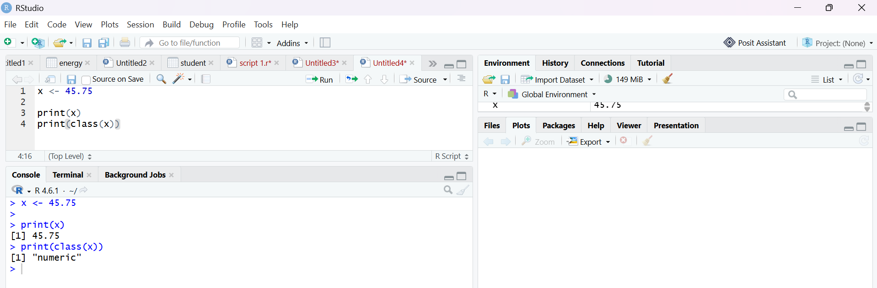

5. Write an R program to calculate the area of a circle using a numeric radius value
entered by the user.
Program
r <- 5
area <- pi * r * r
area
Output
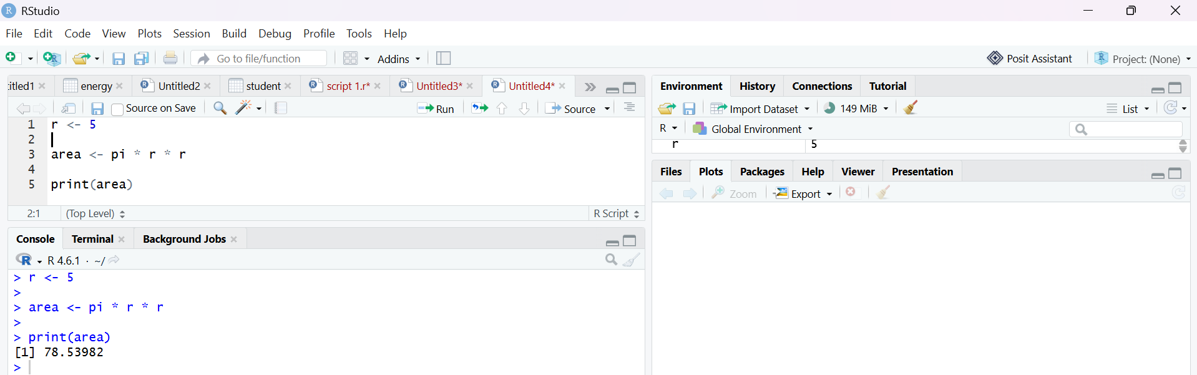
6. Write an R program to create a numeric vector containing five decimal values and
find the maximum and minimum values.
Program
x <- c (12.5, 25.7, 8.4, 45.2, 18.9)
max(x)
min(x)
Output

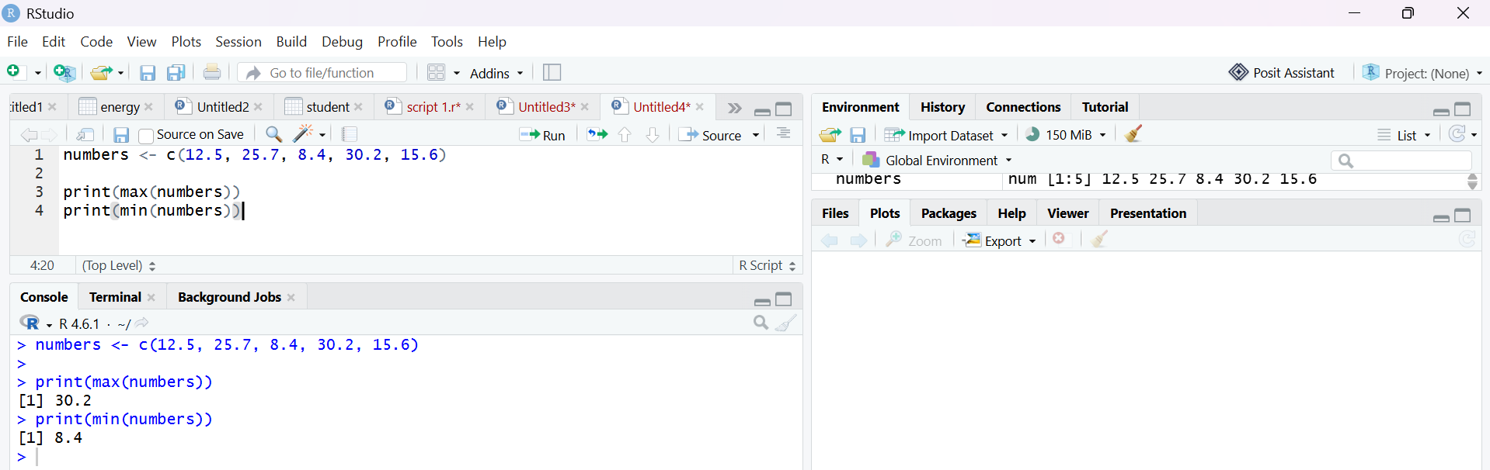

Complex Data Type
7. Write an R program to create a complex number and display its real and imaginary
parts.
Program
x <- 5 + 3i
Re(x)
Im(x)
Output

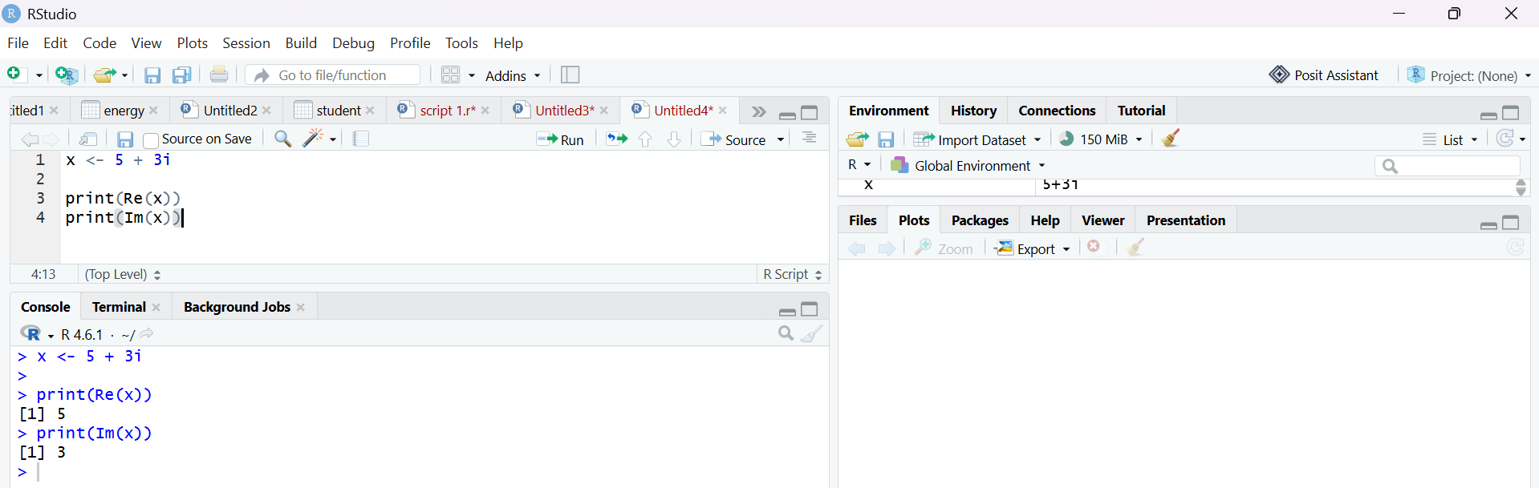
8. Write an R program to create two complex numbers and perform addition,
subtraction, and multiplication operations.
Program
a <- 2 + 3i
b <- 4 + 2i
a + b
a - b
a * b
Output
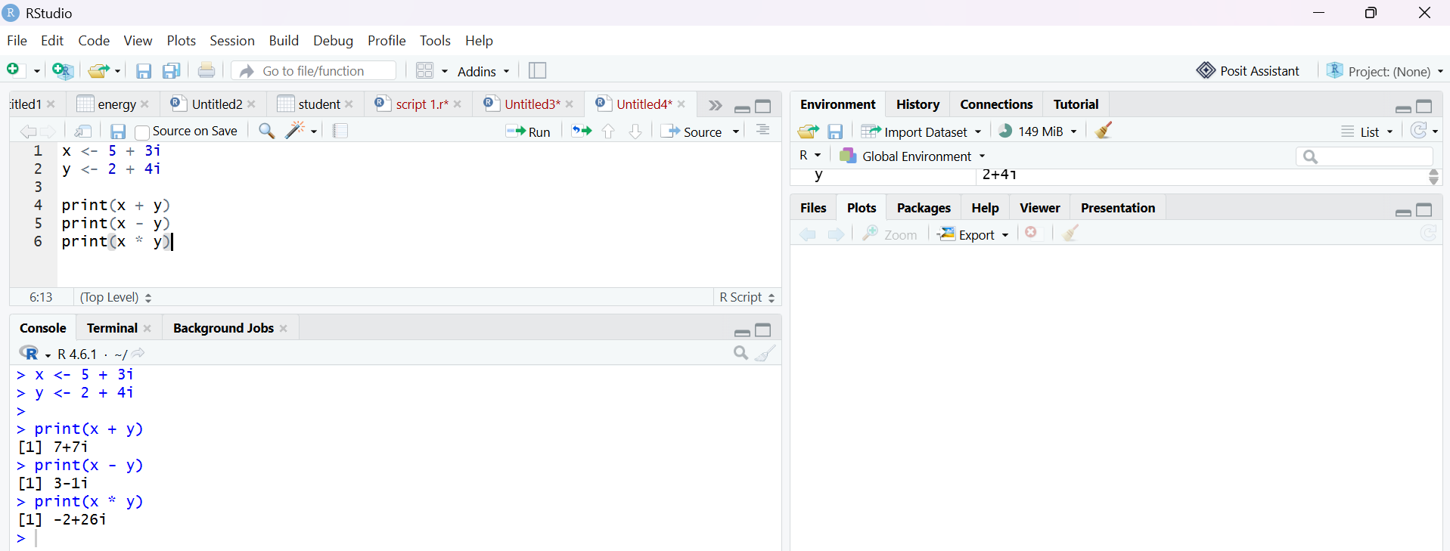
Logical Data Type
9. Write an R program to compare two numbers and store the result in a logical variable.
Display whether the first number is greater than the second.
Program
a <- 25
b <- 15
x <- a > b
x
Output

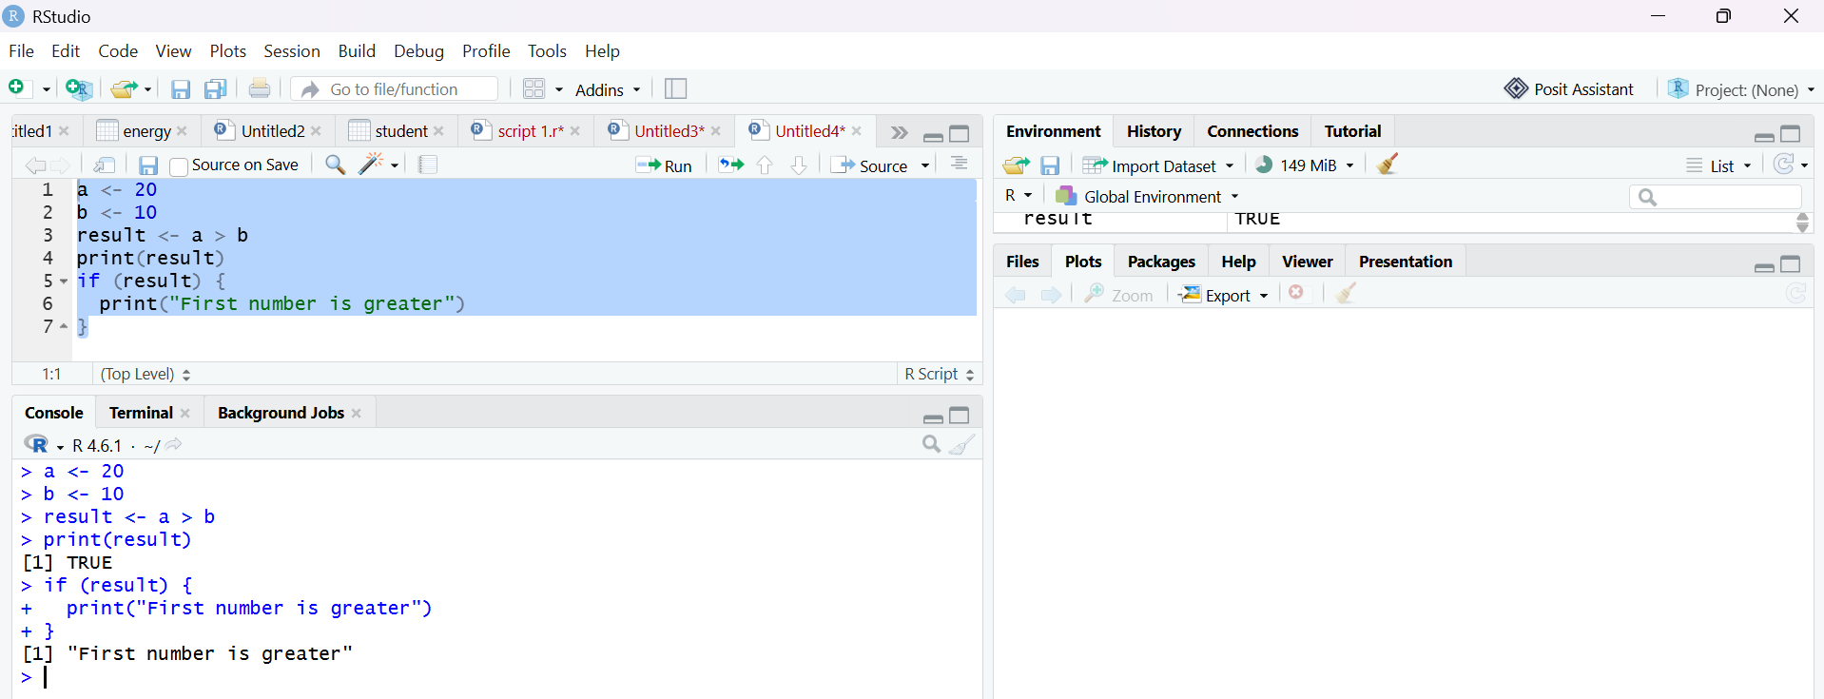

10. Write an R program to create two logical variables (TRUE and FALSE) and
demonstrate the use of logical operators &amp;, |, and !.
Program
a <- TRUE
b <- FALSE
a & b
a | b
!a

Output